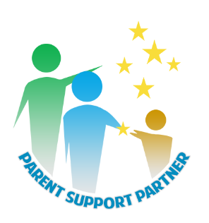
PARENT SUPPORT PARTNER
PRE TRAINING QUESTIONAIRE

Name:
Agency:
Cohort:

- What is your understanding of the role of the Parent Support Partner?

- Why do you want to become a Parent Support Partner?

- What does “Empowerment” mean to you?

- How do you feel you can used your lived experience or story to support or encourage others?

- What do you hope to learn at the Parent Support Partner training?

