Discovering the Superhero  Within Us All!  ACMH 2019 Annual Conference  September 30, 2019 |  |  | 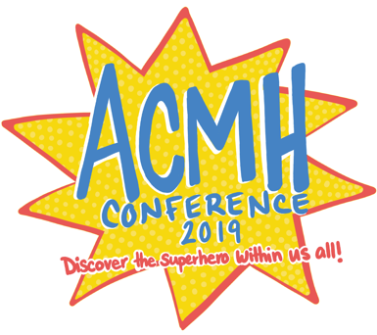
Agenda At a Glance
8:15 - 9:00 | Registration
9:00 – 9:15 | Welcome & Introductions Jane Shank, ACMH Executive Director
9:15 – 10:30  Ballrooms | Plenary Session ~ Superhero’s Panel
10:30 – 10:45 | Break
 | Breakout Session 1 | Breakout Session 2 | Breakout Session 3
10:45 – 12:00 | The Hero’s Journey: Youth Perspectives on Substance Use Disorder and  Mental Health  Capital IV | Current Policy Issues  in Children’s Mental Health  Capital III | Improving Communication in Special Education Meetings & IEP’s  No Superpowers Required!  Michigan I & II
12:00 – 1:15 | Lunch
1:15 - 2:30 | Updates from the Michigan Department of Health and Human Services- Part 1  Capital IV | Parent Voice –  You Can Do It!  Even Without A Superpower!  Capital lll | How to Use  Social Media  to Enhance Your Superpowers for Good  Michigan l & ll
2:30 – 2:45 | Break
2:45 – 4:00 | Updates from the Michigan Department of Health and Human Services- Part 2  Capital IV | Using Community Organization Tools and Methods for The Benefit of Rural Children and Their Families  Capital III | You Don’t Need Superpowers to  Start or Run a Family Support Group…  But an ACMH Toolkit Might Help!  Michigan I & II

