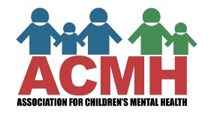
2021 ACMH Parent Leadership Camp
Registration
Name (First, Last)
I prefer to be called
Street Address
City ST ZIP
Primary Phone |  | home other (specify)  cell ____________
Alternate Phone |  | home other (specify)  cell ____________
Email

Special needs or concerns we need to know (please use the back for more space if needed, box will expand if you are completing electronically)

Signature |  | Date

Please return completed forms to lmarshall@acmh-mi.org

2021 ACMH Parent Leadership Camp
Media Release

I, ____________________________ give my permission for the Association for Children’s Mental Health to print or publish (including electronically), or share via ACMH social media platforms my name, artwork, poetry, photographs, and video of me and/or to use quotations from me to inform others about the ACMH Parent Leadership Event and activities. This information will not be used by ACMH for any other purpose.

Signature: ________________________________

Date Signed: __________________

Please return completed forms to lmarshall@acmh-mi.org

2021 ACMH Parent Leadership Camp
Release to Record

I, ____________________________, give my permission for the Association for Children’s Mental Health to record the 2020 virtual Parent Leadership Event to use the on the ACMH website and social media platforms, and to inform others about ACMH parent leadership activities. This information will not be used by ACMH for any other purpose.

Signature: ________________________________

Date Signed: __________________

Please return completed forms to lmarshall@acmh-mi.org

