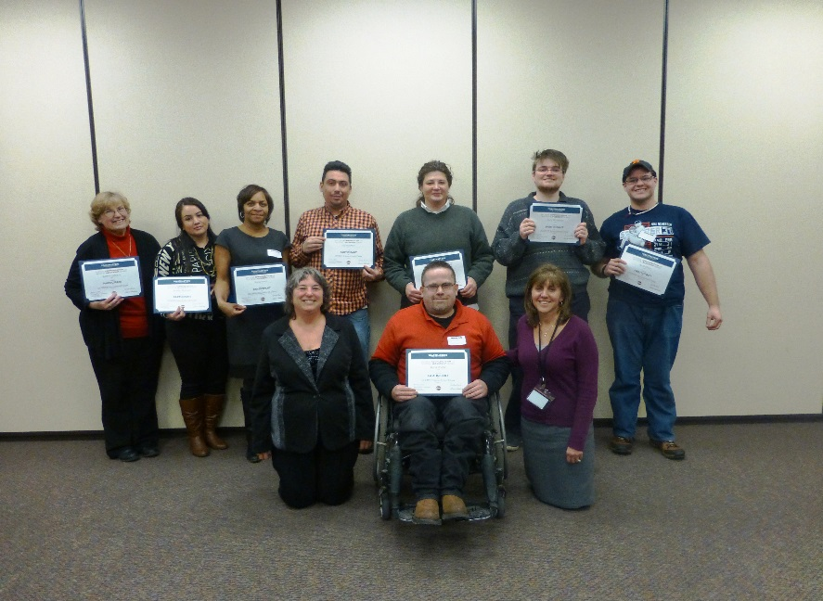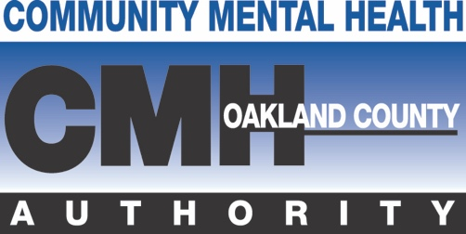

**Learn   
 &**

**Have Fun**

**Learn the basic parts of a good speech.**

**Speak more comfortably in front of people.**

**Practice giving speeches in a small group setting.**

**UPCOMING SESSIONS**

**WHEN: January 26 - March 15, 2016 (Every Tues.)**

**TIME: 1:30 - 3:30 p.m.**

**WHERE: MORC**

**1270 Doris Rd.**

**Auburn Hills, Michigan, 48326**

***This class is open to persons receiving services, family   
 members, CMH staff, and provider staff.***

* **Visit** [**www.occmha.org**](http://www.occmha.org)
* **Click on Training Schedule**
* **Click on January 26, 2016 Speechcraft**
* **Complete required information**
* **Or contact Beth Jacobs at (248) 858-1795 if need help**

**JOIN SPEECHCRAFT**