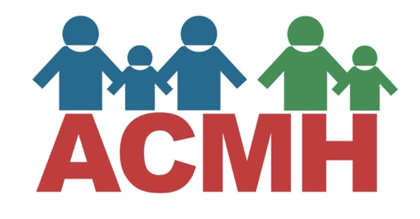
Back to School Resource Links

On Our Sleeves
On Our Sleeves Back to School Guide
On Our Sleeves Coronavirus Behavioral Health Resource Page
How To Prepare for a Return for an Abnormal School Year Video
Schedules and Routines Downloadable Sample Schedules
How To Help Kids Develop Health Habits Checklists for At Home or In School Learning

Child Mind Institute
Preparing for Back-to-School Success – How to Help Kids Thrive, Despite the Uncertainties
Back to School Anxiety During Covid-19 How To Help Kids Handle Fears & Gain Independence
K-2: Tips for Supporting Learning at Home – How to help young children get the most out of remote education
Supporting Families With Positive Behavioral Interventions & Supports (PBIS) At Home
Managing Your Own Anxiety During School Re-Opening
Tips for Partnering With Teachers in the New School Year
How to Set Priorities This School Year – What to Do When You Can’t Do It All

Children’s Mental Health Ontario
Back to School Mental Health Kit
Six Tips to Support Your Child’s Mental Wellness and Prepare for the Start of the School Year
Navigating the School System: Laying the Groundwork for a Successful Return to School for Children with Mental Illness
Back-to-School Tips for Parents
Tips for Encouraging and Supporting Friendships During the School Year

Understood.Org
Back-to-School Anxiety in Kids: What to Watch Out For This Year
Social Anxiety During Social Distancing: How to Help Your Child Cope
Helping Students Cope With Change and Disruption for Teachers

Mental Health America
Back to SchoolMental Health Toolkit

Michigan Alliance for Families –provides information, training and support, to help families prepare for the return to school while ensuring their child’s special education needs are met.

Additional Resources to Support You and Your Kids As They Return to School
Preparing Kids for an Unconventional School Year
Back to School Concerns About Your Child – How to Act On Them
Distance Learning Meet ADHD Again: How to Learn Remotely With ADD
Back to School Anxiety During Covid-19
Missing How Things Used to Be – Tip-sheet for Youth to Understand and Manage Their Feelings of Loss
Teenagers and Re-opening -Tips for Keeping Kids Safe During a Confusing Time
Getting Kids to Work with You During the Coronavirus Crisis – Increasing Cooperation in Kids With Autism
10 Ideas for Keeping Students with Diverse Learning Needs Engaged at Home
Distance Learning Meets ADHD – How to Learn Remotely with ADD Attitude Magazine

Technology Resources
Institute Zoom Tutorial Video For Computers
Institute Zoom Tutorial Video For Tablets

Resources to Support Kids to Wear Masks
Masks and New Routines: Helping Children with Special Needs During COVID-19
7 Tips to Help Your Child Wear a Face Mask

Michigan Back to School State Information, Resources and Guidelines
MI Safe Schools Roadmap
Michigan Alliance for Families Education Covid-19 Resource Page
Michigan Department of Education Covid-19 Information and Resource Page
Michigan Virtual Michigan Cares Free Online Learning Portal for Michigan Families: A portal offering Free digital lessons designed to help students in grades K-12 develop the skills required for social, emotional, and mental well-being will be available to parents, teachers and youth until the end of the 2020-21 school year

CDC Resources & Family Checklists
CDC- Back to School Planning: Checklists to Guide Parents, Guardians, and Caregivers
CDC Checklist for In-Person Classes
CDC Checklist and Planning for Virtual or At-Home Learn

Resources for Students Who Receive Special Education Services
Michigan Alliance for Families Education Covid-19 Resource Page
Michigan Department of Education Guidance for Return to School For Students With IEPS
Modifying an IEP or 504 for Distance or Hybrid Learning – How to help kids get essential school supports

Resources for College Age Students/Young Adults
Should I Attend College in the Fall_ Questions for Students with Mental Health Conditions to Consider
Finishing College Classes During COVID-19
Working from Home During the COVID-19 Pandemic
How Young Adults Can Manage Loss of Income During the COVID-19 Pandemic

All of the above resources are shared on the ACMH Back to School Resource Page.
For other Covid-19 resources for families click here.
Or you can contact Terri at thenrizi@acmh-mi.org for additional information.

