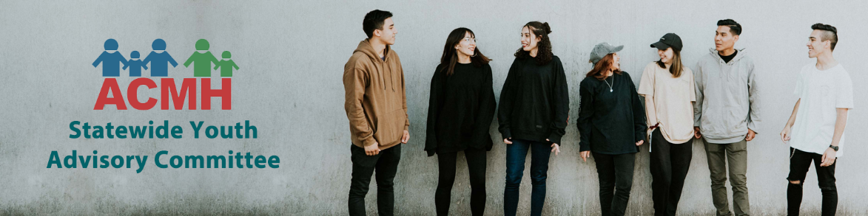

Overview
The Association for Children’s Mental Health (ACMH) is currently accepting applications for its Statewide Youth Advisory Committee. Application for a seat on the ACMH youth advisory committee is open to all youth, ages 15-20 in the state of Michigan who have had or are currently experiencing a mental health or behavioral challenge. Involvement is NOT limited to young people with experience in any particular system, such as public mental health, foster care, juvenile justice or special education. All youth ages 15-20 who are passionate about mental health issues and have personal experience will be considered.
Up to 15 youth will be selected to serve on the committee. Once selected, youth members will be asked to serve for one year. Committee meetings will be held once monthly via technology. Face to face meetings and events will be scheduled when possible. Members will be expected to attend and fully participate in committee meetings and events; if the youth cannot attend a meeting or event they must contact the ACMH Youth Coordinator in advance. Meetings may be photographed, videotaped or recorded.

Committee Purpose and Objectives:
The purpose of the ACMH youth advisory committee is to provide the opportunity for youth with personal mental health experiences to have a voice in decision making that affects their lives. The youth advisory committee will empower and support all Michigan Youth to create positive changes in policies that impact them, giving them the opportunity to advise legislators, mental health administrators and community members about important issues that matter to youth. The committee will have the following objectives:
- Advising ACMH and other state leaders about the experiences and interests of youth with mental health challenges;
- Promoting youth voice in decisions impacting Michigan youth;
- Providing opportunities for young people to develop leadership skills and become active citizens;
- Fostering and supporting partnerships and relationships between youth and adult leaders throughout the state.

Roles and Responsibilities of Youth Advisory Committee Members:
Each ACMH Youth Advisory Committee member will play an essential role in raising awareness and integrating youth perspective into Michigan policies and legislation. All committee members will be asked to:
- Commit to serving on the committee for 1 year;
- Represent the voices of local youth by discussing issues that are important in their communities;
- Possess and demonstrate a strong desire to advocate for positive systems change for youth with mental health difficulties;
- Attend and fully participate in scheduled meetings and events- if the youth cannot attend a meeting or event they must contact the ACMH Youth Coordinator in advance;
- Work closely and collaboratively with fellow youth committee members, adult allies and their identified adult sponsor;
- Submit reports to ACMH advisory committee leader regularly with recommendations regarding youth related issues and committee activities.

Criteria for Participation:
- Be between the ages of 15-20 years old;
- Have had personal experience or are currently dealing with a mental health or behavioral challenge;
- Possess the passion and desire to advocate for positive systems change for children’s mental health;
- Have the ability to work in collaboration with fellow committee members. This includes:
  - Respectfully conveying their thoughts and opinions
  - Listening to and integrating opinions of others
  - Providing supportive feedback to others in a respectful way
  - Conducting themselves with maturity in a professional environment
  - Demonstrating an openness and willingness to gain further professional skills

Benefits for Participation:
- Gain leadership skills
- Have your voice heard by adult decision makers and represent youth from local communities
- Connect with other youth and learn from their experiences
- Build your resume and school applications
- Create positive changes for Michigan youth
- And more!!

How to Get Involved:
Interested youth who meet criteria for participation will follow the required steps to submit an application. By doing so, youth agree to fulfill the roles and responsibilities as described.
As part of their application process, applicants will be asked to select an adult sponsor to help support them in their participation on the committee. This sponsor will:
- Provide a letter of recommendation, speaking on the strengths the youth will bring to the committee;
- Serve as a mentor to the youth;
- Support the youth’s involvement in committee meetings, events and related activities;
- Help connect youth to leadership trainings, educational events, and development opportunities in their local community.
Examples of adult sponsors may include employees or volunteers of youth serving organizations, therapists, coaches, neighbors, teachers, etc. The ACMH Youth Coordinator can help the applicant identify a sponsor if needed.

Please contact Sara Reynolds with any questions at 517-643-3544 or SReynolds@acmh-mi.org

